**EXP 3 : DESIGN AN DOOR BELL USING A PUSH BUTTON**

**THEORY**

**CIRCUIT DIAGRAM:** 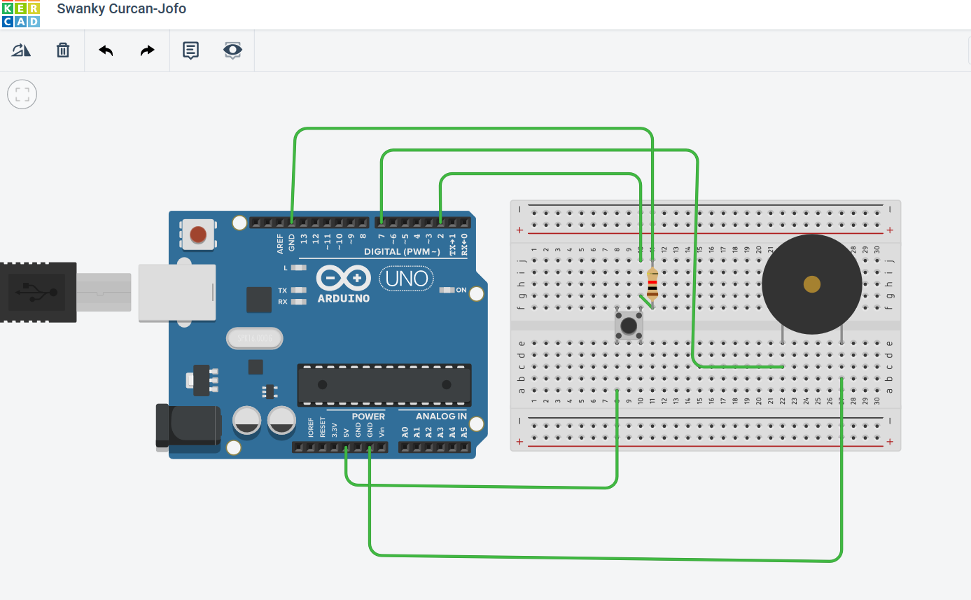

**CONCEPT USED :** In this experiment first we used the basics of electronics in connecting the breadboard connections and the concept of the connections of the Arduino with the bulb and the button.

**LEARNING AND OBSERVATIONS**:

Through this experiment we can learn the use and the applications of Arduino and the breadboard .

We can also learn the basic level of coding for the Arduino from this experiment .

We can observe when we click the push button the bulb connected starts glowing.

**PROBLEMS AND TROUBLESHOOTING :**

We mainly face problems in making the properconnections in the breadboard and the connections of bulb and resistor .

And the code of the Arduino should be given properly.

**PRECAUTIONS :**

One should be very consciouswhile making the connections of breadboard and arduino.

And also the code of Arduino should be checked twice.

The use of extra connecting wires should be decreased.

**LEARNING OUTCOMES :**

We can Learn the a real life application from this experiment, the door bell system which is mostly used by everyone.

We can also learn the basic coding for the Arduino .